Wheat

Wheat is a cereal grain. People eat it most often in the form of bread. It is a kind of grass whose fruit is a "head of wheat" with edible seeds. It was first grown in the Levant, a region of the Near East. Now it is cultivated worldwide.
World trade in wheat is greater than for all other crops combined.Globally, wheat is the leading source of vegetable protein in human food. It has a higher protein content than other major cereals such as maize (corn) or rice. In terms of total production, it is second to rice as the main human food crop and ahead of maize.
Wheat was a key factor enabling the emergence of city-based societies at the start of civilization. It was one of the first crops that could be easily cultivated on a large scale, and its seeds could be stored for long periods in a dry climate. Wheat helped the growth of city-states in the Fertile Crescent, including the Babylonian, Assyrian and persian empires.
Wheat grain is a staple food used to make flour for leavened, flat and steamed breads, biscuits, cookies, cakes, breakfast cereal, pasta, noodles, couscous. It can also be fermented to make ethanol,for alcoholic drinks, or biofuel.
An allergy to wheat can cause coeliac disease, which makes the sufferer have diarrhoea if they eat any food containing wheat.

Wheat Growth and Development:

Wheat can be classified as winter or spring growth habit based on flowering responses to cold temperatures. Winter wheat development is promoted by exposure of the seedlings to temperatures in the 38 degrees to 46 degrees F range. Such types are usually planted in the fall which exposes the seedlings to cold temperatures during late fall and winter. Spring-types, however, do not require exposure to cold temperatures for normal development and can be planted in spring. Both winter- and spring-types, when properly grown, head in the late spring or early summer and mature by mid- to late-summer.

- Schematic diagram of wheat growth and development stages, periods of initiation or growth of specific organs and periods of different components of grain yield
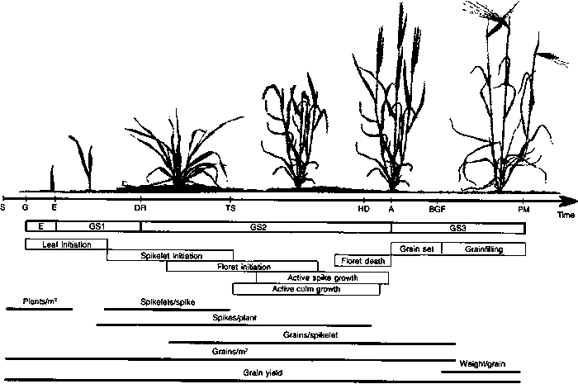

- Days from emergence to physiological maturity in a spring and winter wheat

Development stage | Time (days)
Development stage | Spring 1ª | Winter 2^{b}
Emergence | 0 | 0
Floral initiation (double ridge) | 20 | 35
Terminal spikelet | 45 | 60
First node | 60 | 80
Heading | 90 | 120
Anthesis | 100 | 130
Physiological maturity | 140 | 170
- Development of unvernalized wheat cultivars when days were extended by 0 hours (a) and 3 hours (b)

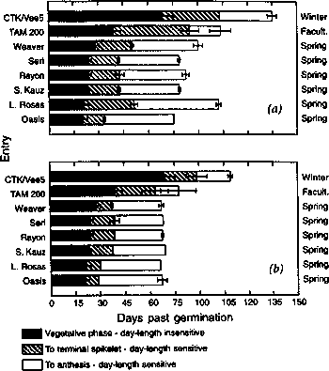

- Relationship of grain yield to seasonal evapotranspiration for irrigated and dryland wheat crops

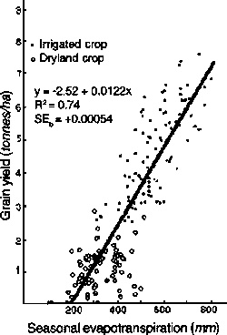
- Indian Wheat Growing Zones:The entire wheat growing areas of the country has been categorized into 6 major zones as follow

Zones | States/Regions Covered | Approx Area(million ha)
Northern Hill Zone(NHZ) | Hilly areas of J&K( except Jammu, Kathua and Samba districts), Himachal Pradesh ( except Una & Paonta valley),Uttarakhand(excluding Tarai region) & Sikkim | 0.8
North Western Plains Zone(NWPZ) | Punjab,Haryana,Western UP(except Jhansi Div),Rajasthan (excluding Kota & Udaipur div),Delhi, Tarai region of Uttarakhand, Una & Paonta valley of HP, Jammu,Samba & Kathua districts of J&K and Chandigarh. | 11.55
North Eastern Plains Zone(NEPZ) | Eastern UP(28 dist),Bihar,Jharkhand,West Bengal,Assam, Odisha and other NE states (except Sikkim) | 10.5
Central Zone | MP,Gujarat,Chattisgarh,Kota & Udaipur Div of Rajasthan & Jhansi Div of UP. | 5.2
Peninsular Zone | Maharashtra, Tamil Nadu(except Nilgiris & Palani Hills),Karnataka & Andhra Pradesh | 1.6
Southern Hill Zone(SHZ) | Nilgiris & Palani Hills of Tamil Nadu | 0.1

- Major wheat production state

